 CHEMICAL ENGINEERING TRANSACTIONS  VOL. xxx, 2026 | A publication of  
The Italian Association
of Chemical Engineering
Online at www.cetjournal.it

Guest Editors: Marco Bravi, Antonio Marzocchella, Giuseppe Caputo
Copyright © 2026, AIDIC Servizi S.r.l.
ISBN 979-12-81206-xx-x; ISSN 2283-9216

Combined Growth Kinetics and Scale-Up Criteria for Designing CHO Cell Bioreactors
Daniela De Cata*, Leone Mazzeo, Vincenzo Piemonte
Faculty of Engineering, Unit of Chemical-physics Fundamentals in Chemical Engineering, University Campus Bio-medico of Rome, Via Alvaro del Portillo, 21, 00128, Rome, Italy
*daniela.decata@unicampus.it
The scale-up of Chinese Hamster Ovary (CHO) cell bioprocesses presents significant challenges, particularly in ensuring uniform and adequate oxygen transfer throughout the reactor, while simultaneously limiting shear stress generated by the impellers, to which CHO cells are highly sensitive. This work proposes a practical and integrated approach that combines kinetic mathematical modeling with key scale-up design criteria, enabling the simultaneous consideration of the main constraints involved in CHO bioreactor design. The methodology not only ensures the achievement of the desired production target, but also supports optimal reactor design and operating conditions. The proposed framework was demonstrated through a case study, proving its robustness and reliability.
  - Introduction
Chinese Hamster Ovary (CHO) cells are commonly employed as a host for producing various recombinant proteins for therapeutic applications (Jayapal et al.2007). However, to optimize the use of bioreactors in industrial applications, it is necessary to account for a multitude of factors that affect system performance. First, in order to express the gene encoding the desired product, the numerous genetic modifications introduced into CHO cell lines, together with the wide variety of culture media employed, make each experimental configuration essentially unique and difficult to generalize. In fact, the different combinations of genetic engineering strategies and culture conditions significantly influence cell growth kinetics, metabolic fluxes, specific productivity, the formation of catabolites, and inhibitory phenomena (Pereira et al., 2018). Therefore, it is essential to identify the predominant influencing factors and the most suitable relationships to describe their interdependencies. From a scale-up perspective, a dedicated mathematical model capable of representing these phenomena, by selecting only the kinetically relevant contributions and neglecting secondary effects, constitutes a fundamental tool for understanding the physiological requirements of CHO cells, such as oxygen and nutrient uptake, the mechanisms of cell growth, and for optimizing the process to achieve the desired industrial production target. However, during scale-up, it is equally important to account for system non-idealities already at the design stage. These include imperfect mixing, oxygen transfer to the liquid phase, shear stresses induced by mechanical agitation, and the power input regimes involved. Establishing an effective scale-up strategy that systematically incorporates all these factors is therefore essential for reactor optimization (Xing et al. 2009). For this reason, this work aims to provide a scale-up tool for CHO cell bioreactors that integrates mathematical modelling with the key bioreactor design and scale-up criteria, to optimize operating conditions and ensure process robustness. A case study based on literature data is presented to validate the effectiveness of the proposed approach.
  - Materials and methods
    - Mathematical model
To determinate the optimal operating conditions required to achieve the desired target, it is essential to identify and accurately describe the key phenomena governing the system. The data for the case study are taken from the work of Noh et al. (2016), in which the growth of some CHO cell lines is analyzed as a function of substrate consumption and catabolite production in a batch configuration. For this reason, the correlated model proposed in this work for the case study focuses on the consumption of the main substrates, glucose (Glc) and glutamine (Gln), and on the production of the principal catabolites, lactate (Lac) and ammonia (Amm). These species are involved in the following main metabolic pathways: aerobic glucose consumption (Eq. 1), aerobic glutamine consumption (Eq. 2), and anaerobic glucose consumption (Eq. 3).
$$Glc+6O_{2} →6CO_{2}+6H_{2}O$$ | (1)
$$3Gln+8O_{2}+2H_{2}O→7{CO}_{2}+6Amm+3Lac$$ | (2)
$$Glc →2Lac+2H_{2}O$$ | (3)
In a batch system the biomass X growth can be described with the Eq. 4:
$$\frac{dX}{dt}= μ_{x}X X\left(0\right)=X_{0}$$ | (4)
Where $μ_{x}$ is the growth rate of the biomass depending by the three metabolic paths (Eq. 5), and includes the aerobic contribution $μ_{aer}$, the anaerobic contribution $μ_{anaer}$, and the inhibition terms due to the presence of the catabolites $I_{Lat}$ and $I_{amm}$.
$$μ_{x}= μ_{max}\left(γ_{aer}μ_{aer}+γ_{anaer}μ_{anaer}\right)I_{Lat}I_{amm} with γ_{aer}+γ_{anaer}=1$$ | (5)
$μ_{aer}$ is dependent by the consumption of both Glc and Gln (Eq. 6).
$μ_{aer}= γ_{Glc}μ_{Glc}+γ_{Gln}μ_{Gln}$ $with γ_{Gln}+γ_{Glc}=1$ | (6)
$μ_{Glc}$ and $μ_{Gln}$ are described by Monod-type kinetics and are coupled with oxygen consumption (Eq. 7).
$$μ_{i}=\left(\frac{C_{i}}{K_{i}+C_{i}}\right)\left(\frac{C_{o_{2}}}{K_{O_{2}}+C_{O_{2}}}\right)$$ | (7)
$μ_{anaer}$ is dependent by the Glc consumption and inhibited by the oxygen as follow (Eq. 8):
$$μ_{anaer}=\left(\frac{C_{Glc}}{K_{anaer}+C_{Glc}+\frac{C_{o_{2}}^{2}}{K_{I}}}\right)$$ | (8)
Finally, the growth inhibition terms of Lac and Amm are represented by Eq. 9.
$$I_{i}= \frac{K_{I,i }}{K_{I,i}+C_{i}}$$ | (9)
Regarding the consumption rates of the substrate Glc and Gln, they are expressed by the Eq. 10 and Eq. 11, respectively.
$$\frac{dC_{Glc}}{dt}=- μ_{max}\left(\frac{1}{Y_{Glc}}γ_{aer}γ_{Glc}μ_{Glc}+\frac{1}{Y_{anaer}}γ_{anaer}μ_{anaer}\right)X C_{Glc}\left(0\right)=C_{Glc}^{0}$$ | (10)
$$\frac{dC_{Gln}}{dt}=- μ_{max}\frac{1}{Y_{Gln}}γ_{aer}γ_{Gln}μ_{Gln}X C_{Gln}\left(0\right)=C_{Gln}^{0}$$ | (11)
The mass balance of the oxygen accounts its consumption for the aerobic respiration and its transfer from the gas to the liquid phase (Eq 12):
$\frac{dC_{O_{2}}}{dt}=- μ_{max}γ_{aer}\left(\frac{1}{Y_{O_{2}/Gln}}γ_{Gln}μ_{Gln}+ \frac{1}{Y_{O_{2}/Glc}}γ_{Glc}μ_{Glc}\right)X+k_{L}a(C_{o_{2}}^{*}-C_{o_{2}}) C_{O_{2}}\left(0\right)=C_{O_{2}}^{0}$ (12)
Finally, the production of the catabolites is described by Eq. 13 for the lactate and the Eq. 14 for the ammonia.
$$\frac{dC_{Lac}}{dt}=μ_{max}\left(\frac{1}{Y_{Lac/Gln}}γ_{aer}γ_{Gln}μ_{Gln}+\frac{1}{Y_{O_{2}/Gln}}γ_{Glc}μ_{Glc}\right)X-μ_{lac}\left(\frac{C_{lac}}{K_{lac}+C_{lac}} \right)\left(\frac{K_{g}}{K_{g}+C_{Glc}}\right)X$$  $$C_{Lac}\left(0\right)=C_{Lac}^{0}$$ | (13)
$\frac{dC_{Amm}}{dt}=μ_{max}\frac{1}{Y_{Amm/Gln}}γ_{aer}γ_{Gln}μ_{Gln}X C_{Amm}\left(0\right)=C_{Amm}^{0}$ | (14)
It is important to note that, as described in Eq. 13, lactate can be consumed by CHO cells following a metabolic shift from lactate production, occurring in the presence of glucose, to lactate consumption after glucose depletion, leading to a more energy-efficient metabolic state during the stationary phase (Martínez et al., 2013).
Using experimental data available in the literature, it was possible to estimate the kinetic parameters specific to the system, including Monod constants, inhibition constants, and yield coefficients. The simulations were performed using the gPROMS software, where the time domain was discretized through a backward finite difference method. Parameter estimation was conducted using the gPROMS Parameter Estimation tool.
    - Combination of the mathematical model with the reactor scale up strategies
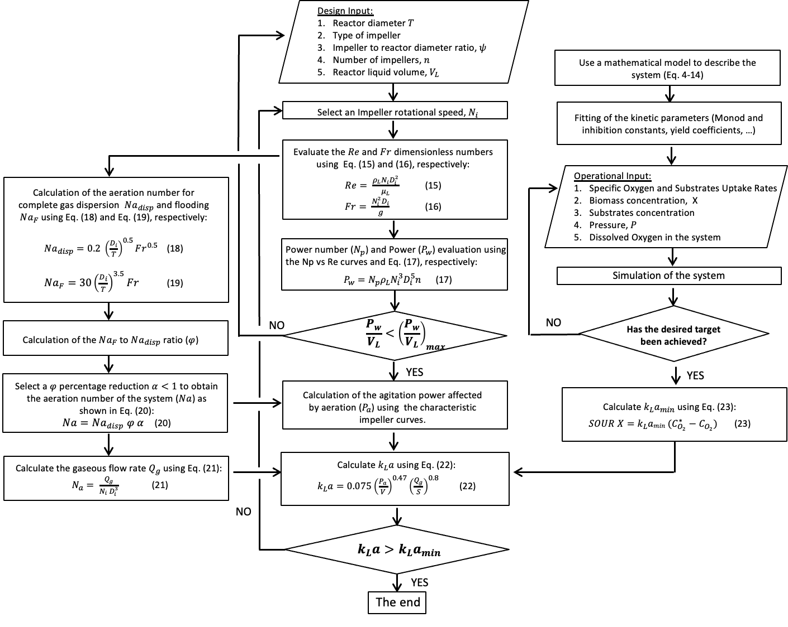
Figure 1: Proposed scheme used in the case study for the combination of the mathematical model with the scale-up criteria in case of CHO cells bioreactors

From the model simulations, it is possible to identify the optimal operating parameters required to achieve the desired target (e.g., daily productivity and limits on catabolite and undesired secondary products formation). However, these parameters alone are not sufficient to ensure a robust system at the design stage: they must be integrated with well-established design choices that account for the limitations and non-idealities of the bioreactor. The scheme that combines these two approaches is shown in Figure 1. From the right column of Figure 1, it can be observed that, once the operating parameters ensuring the target achievement have been identified, it is possible to calculate the minimum oxygen mass transfer coefficient $k_{L}amin$ required to guarantee an adequate oxygen concentration inside the bioreactor (Eq. 23). Oxygenation is in fact one of the most critical aspects in CHO bioreactors, as it requires an efficient and homogeneous transfer of oxygen to the liquid phase, which can only be achieved through proper design of the reactor, the impellers, and the aeration system. Once the reactor design inputs have been defined (central column of Figure 1), the effective $k_{L}a$ of the designed system can be calculated and verified to be higher than the minimum value derived from the model. Among the design inputs, the choice of the impeller type and its sizing are fundamental parameters. Referring to the central column of Figure 1, the impeller rotation speed $N_{i}$is the most easily adjustable parameter, as it directly determines the power supplied to the system to ensure proper mixing. This power can be obtained from the correlations between the Reynolds number (Eq. 15) and the power number $N_{p}$, an empirical parameter characteristic of the impeller type, from which the power of the impellers $P_{w}$can be calculated using Eq. 17. In general, as $P_{w}$increases, mixing, and mass transfer also increase. However, CHO cells are highly sensitive to shear stress, and therefore a maximum allowable value of $P_{w}/V$exists, reported in the literature to be around 1000 W/m³ (Kenmoku et al., 2025). $P_{w}$represents the power required in the case of a liquid-only phase. In the presence of the gas phase, which contributes to mixing, the effective required power is lower. To determine the effective power $P_{a}$​, the aeration number $N_{a}$is introduced, referring to the left column of the graph in Figure 1. The value of $N_{a}$ must be selected so that it does not fall below the minimum for complete gas dispersion $N_{a},disp$(Eq. 18) and does not exceed the limit value beyond which the floating phenomenon occurs $N_{a,F}$ (Eq. 19). Both the aeration number are dependent by Fr number (Eq.16). For this reason, a corrective factor ϕα is introduced to ensure that $N_{a}$remains within this interval (eq. 20), where ϕ is the ration between $N_{a,F}$ and $N_{a, disp}$, and α is corrective factor <1. Then, it is possible to calculate $P_{a}$​ using the characteristic impeller curves and to determine the gas flow rate $Q_{g}$(Eq. 21). Finally, the effective $k_{L}a$ of the system can be calculated using Eq. 22 and verified to be greater than the minimum value required to ensure proper system operation. If this condition is not satisfied, the impeller rotational speed $N_{i}$ can be increased and the procedure repeated. Although this results in a higher power demand, it positively enhances the mass transfer coefficient.
  - Results and discussion
    - Fitting of the kinetic parameters
The kinetic parameters and yield coefficients were estimated using the model described in Section 2.1; the results are reported in Table 1 and Table 2, respectively. Since no experimental data on oxygen were available, the yield coefficients $Y_{O_{2}/Glc}$ and $Y_{O_{2}/Gln}$ were determined according to stoichiometric considerations. For typical aerobic CHO cell systems, $γ_{aer}=0.8$ and $γ_{Glc}=0.7$. Finally, the $k_{L}a$ value was assumed to be 0.0111 s⁻¹, which is representative of laboratory-scale batch bioreactors (Moucha et al., 2003).
Table 1: Kinetic fitting parameters results
$μ_{max}$ [h⁻¹] | $μ_{Lac}$ [h⁻¹] | $K_{Glc}$ [g/L] | $K_{Gln}$ [g/L] | $K_{anaer}$ [g/L] | $K_{O_{2}}$ [g/L] | ${ K}_{I}$ [g/L] | $K_{I, Amm}$ [g/L] | $K_{I, Lac}$ [g/L] | $K_{lac}$ [g/L] | ${ K}_{g}$ [g/L]
0.14233 | 47.72 | 3.01 | 0.496 | 0.403 | 0.05 | 5.02 | 0.018 | 0.388 | 0.001 | 1.085
Table 2: Yield coefficient fitting parameters results
$Y_{Glc}$ | $$Y_{Gln}$$ | $$Y_{Lac/Glc}$$ | $$Y_{Lac/Gln}$$ | $$Y_{Amm/Gln}$$
1.1768 | 1e-4 | 03.44e-4 | 3.85e-4 | 5.7e-4

Figure 2 compares the model predictions with the experimental data. Overall, the model represents the system behavior satisfactorily for all the species, with only a slight overestimation of glucose consumption (Figure 2a). In the experimental study, particular emphasis was placed on limiting the production of Amm and Lac. Therefore, the validated model can now be used to simulate the system under the desired operating conditions.
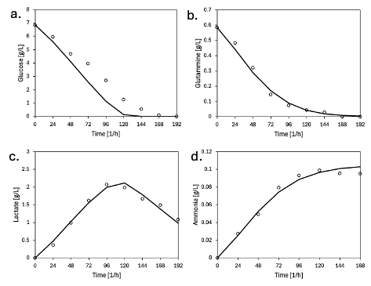
Figure 2: Experimental profiles of substrates and catabolites from Noh et al. (2016) (dots) compared with model predictions (solid lines).
    - Scale up case study
The case study considers a typical industrial production scale, with bioreactors of 5000 L. From the model simulations, it was possible to determine the operational inputs required, according to the scheme in Figure 1, to calculate the minimum $k_{L}a$; these values are reported in Table 3. The dissolved oxygen (DO) concentration was set at 50% of the saturation value (Ahlebooth et al., 2021). Using the procedure of the right column of Figure 1, the minimum $k_{L}a$ calculated for the system is 5.7 x 10⁻³ ${\text{s}}^{-1}$.

Table 3: Operational parameters obtained by model simulation
SOUR [mol ⋅ cell/ h] | X [cell/L] | P [atm] | DO [mg/L]
3.2e-13 | 3e9 | 1 | 4

The design parameter assumptions adopted for the scale-up are reported in Table 4. A marine propeller was selected as the mixing device, as it is commonly employed in CHO cell bioreactors due to its lower shear generation, which helps prevent cell damage. The aeration system consists of a sparger, and the impeller-to-reactor diameter ratio was chosen according to typical values for 5000 L bioreactors (Xing et al., 2008). Assuming that the liquid phase has physical properties similar to those of water, the Reynolds number (Eq. 15) was found to be on the order of ${10}^{6}$, while the Froude number (Eq. 16) was calculated to be 0.191.
Table 4: Design parameters assumptions
T [m] | ψ | n | N_{p} | N_{i} [s⁻¹] | V_{L} [L]
1.2 | 0.56 | 3 | 0.35 | 1.67 | 5000

Following the central column of Figure 1, the impeller power $P_{w}$ must first be determined. A power number $N_{p}$ of approximately 0.35 was selected from the characteristic curve of the chosen propeller (Bailey and Ollis, 2018, Chapter 9) Using Eq. 17, the calculated impeller power $P_{w}$ was 665.7 W, satisfying the constraint that the corresponding power density, 40 W/m³, remains below the maximum allowable limit.
Subsequently, in order to improve energy efficiency, the aeration number $N_{a}$ was evaluated following the left column of Figure 1. The minimum value required for complete bubble dispersion, $N_{a,disp}$, was calculated as 0.085 (Eq. 18), while the upper limit associated with the onset of floating, $N_{a,F}$, was 0.753 (Eq. 19). By applying a corrective factor of 0.3, a value of $N_{a}$ within this admissible range was obtained. From the characteristic curve from Bailey and Ollis (2018, Chapter 9) the effective power in aerated conditions $P_{a}$, was determined to be 199.7 W.
Finally, using Eq. 22, the effective $k_{L}a$ of the designed reactor was calculated to be 0.0311 $s^{-1}$, which satisfies the requirement of being higher than the minimum $k_{La,\text{min}}$.
The reactor design was therefore successfully completed, demonstrating the effectiveness of the proposed approach. In fact, this methodology allows not only the achievement of the process target, but also ensures that the system is properly mixed, adequately aerated, energetically optimized, free from excessive shear stress, and without floating phenomena, thus addressing in an integrated way the main critical issues typical of CHO cell bioreactors.
  - Conclusions
This work proposes a practical and effective tool for the design of CHO cell bioreactors, based on the integration of mathematical modeling with selected scale-up design criteria. The developed approach systematically accounts for the main critical issues typical of these systems, such as oxygen limitation, floating phenomena and non-homogeneous gas dispersion, as well as shear stresses generated by agitation that may damage the cells. These aspects were considered simultaneously through the development of a design algorithm that guides the consistent selection of key design parameters, enabling the development of a reactor that is not only operationally robust and stable, but also efficient with respect to the desired production target. To validate the proposed methodology, a case study based on literature data was presented. The model proved the capability of accurately predicting substrate consumption and catabolite production by fitting the kinetic parameters to experimental profiles. This validation allowed the model to be used to determine the optimal operating conditions of the reactor. These results were subsequently integrated into the scale-up algorithm, leading to the successful and systematic design of a 5000 L bioreactor, satisfying all imposed design criteria. In conclusion, this study presents an effective methodology for the design and optimization of CHO cell bioreactors, while also providing the necessary bibliographic references for a comprehensive understanding of the topic. Furthermore, the proposed framework represents a methodological basis that can be extended to other types of bioreactors, where different constraints and optimization strategies must be considered.
References
Ahleboot, Z., Khorshidtalab, M., Motahari, P., Mahboudi, R., Arjmand, R., Mokarizadeh, A., & Maleknia, S.,2021. Designing a strategy for pH control to improve CHO cell productivity in bioreactor. Avicenna Journal of Medical Biotechnology, 13(3), 123.
Bailey, James E., and David F. Ollis. Biochemical engineering fundamentals. McGraw-Hill, 2018.
Martínez, V. S., Dietmair, S., Quek, L. E., Hodson, M. P., Gray, P., & Nielsen, L. K., 2013. Flux balance analysis of CHO cells before and after a metabolic switch from lactate production to consumption. Biotechnology and bioengineering, 110(2), 660-666.
Moucha, T., Linek, V., & Prokopová, E., 2003. Gas hold-up, mixing time and gas–liquid volumetric mass transfer coefficient of various multiple-impeller configurations: Rushton turbine, pitched blade and techmix impeller and their combinations. Chemical Engineering Science, 58(9), 1839-1846.
Noh, S. M., Park, J. H., Lim, M. S., Kim, J. W., & Lee, G. M., 2017. Reduction of ammonia and lactate through the coupling of glutamine synthetase selection and downregulation of lactate dehydrogenase-A in CHO cells. Applied microbiology and biotechnology, 101(3), 1035-1045.
Jayapal, K. P., Wlaschin, K. F., Hu, W., & Yap, M. G., 2007. Recombinant protein therapeutics from CHO cells-20 years and counting. Chemical engineering progress, 103(10), 40.
Kenmoku, H., Kaneko, A., Saito, T., Nemoto, T., Kato, Y., & Ohira, S., 2025. Scale‐Up Strategy Focused on Hydrodynamic Stress for Mammalian Cell Culture Established by a Dry‐Wet Approach. Engineering in Life Sciences, 25(11), e70054.
Pereira, S., Kildegaard, H. F., & Andersen, M. R., 2018. Impact of CHO metabolism on cell growth and protein production: an overview of toxic and inhibiting metabolites and nutrients. Biotechnology Journal, 13(3), 1700499.
Xing, Z., Kenty, B. M., Li, Z. J., & Lee, S. S., 2009. Scale‐up analysis for a CHO cell culture process in large‐scale bioreactors. Biotechnology and bioengineering, 103(4), 733-746.

